AS-IS / TO-BE Process Flow
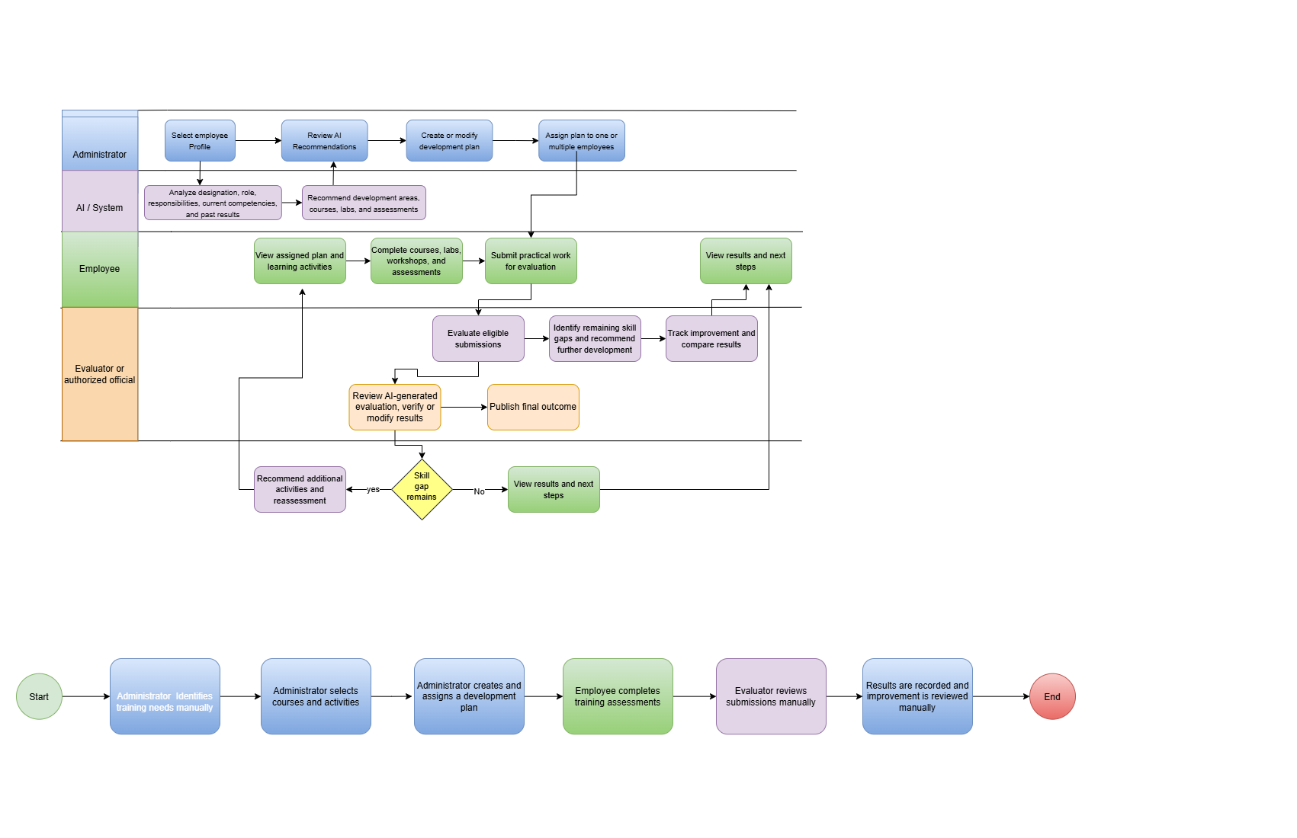

Functional Requirements Document (FRD)
AI-Powered Employee Capability Development & Improvement System

1. Purpose
The purpose of this document is to define the functional requirements for the AI-Powered Employee Capability Development & Improvement System. The system supports employee development through AI-based recommendations, personalized development plans, learning activities, assessment evaluation, and continuous improvement tracking.

2. Scope of the Changed Process
The proposed system replaces the manual identification of development needs, selection of learning activities, evaluation of employee submissions, and tracking of improvement with a centralized, AI-assisted process.
The Administrator manages development plans, the Employee completes assigned learning activities, and the Evaluator/Authorized Official verifies assessment results before publication. AI supports recommendations, preliminary evaluation, and skill-gap analysis. Final evaluation results require human verification.

3. User Roles
User Role | Responsibilities
Administrator | Manages employee profiles, reviews AI recommendations, creates development plans, and assigns plans to employees.
Employee | Views assigned plans, completes learning activities and assessments, and submits practical work.
Evaluator/Authorized Official | Reviews AI-generated evaluations, modifies results when necessary, and publishes verified outcomes.

4. Functional Requirements
4.1 Employee Profile and Development Recommendations
FR-01: Manage Employee Profiles
The system shall allow the Administrator to view and manage employee profiles, including designation, role, responsibilities, current competencies, and previous assessment results.
FR-02: Generate AI-Based Development Recommendations
The system shall analyze the available employee profile and assessment data to recommend development areas based on identified competency gaps.
FR-03: Review AI Recommendations
The system shall allow the Administrator to review, accept, modify, or reject AI-generated development recommendations before creating a development plan.
4.2 Development Plan Management
FR-04: Create and Assign Development Plans
The system shall allow the Administrator to create or modify development plans and assign a plan to an individual employee or multiple employees with similar development needs.
FR-05: Recommend Learning Resources
The system shall recommend relevant courses from an approved learning resource catalogue based on the employee's development needs.
FR-06: Recommend Practical Activities and Assessments
The system shall recommend relevant practical labs, workshops and assessments to help employees develop and demonstrate the required competencies.
FR-07: Track Learning Activities
The system shall allow employees to view assigned development plans, access learning activities, track completion status, and submit required assessment work.
4.3 Assessment and Evaluation
FR-08: Evaluate Employee Submissions Using AI
The system shall evaluate eligible employee submissions against defined assessment criteria and generate provisional scores, competency levels, and feedback.
FR-09: Verify and Publish Evaluation Results
The system shall allow the Evaluator/Authorized Official to review AI-generated evaluation results, modify scores or feedback when necessary, and publish the verified results.
The system shall not publish AI-generated evaluation results as final before verification by the authorized official.
4.4 Skill-Gap Analysis and Continuous Improvement
FR-10: Identify Remaining Skill Gaps
The system shall compare verified employee competency levels with the target competency levels defined in the development plan and identify remaining gaps.
FR-11: Recommend Further Development Activities
The system shall recommend additional learning activities and assessments when the verified results indicate remaining skill gaps.
FR-12: Support Reassessment and Improvement Comparison
The system shall allow employees to complete reassessments when required and compare previous and current assessment results to measure improvement.
FR-13: Display Development Progress
The system shall display relevant development plan status, learning activity completion, assessment results, remaining skill gaps, and improvement data to authorized users according to their access permissions.

5. Business Rules
- The Administrator reviews AI-generated recommendations before assigning a development plan.
- The Administrator can assign the same development plan to multiple employees with similar development needs.
- AI-generated evaluation results remain provisional until the Evaluator/Authorized Official verifies them.
- Only authorized users can review or modify evaluation results and publish outcomes.
- The system recommends further development activities when verified results show that an employee has not achieved the target competency level.
- The system uses verified assessment results to measure employee improvement.

6. Assumptions and Constraints
- Employee profile and assessment data are available to the system.
- The organization maintains an approved catalogue of learning resources and assessment criteria.
- AI recommendations and evaluations depend on the quality and availability of the input data.
- Direct integration with external learning platforms such as LinkedIn Learning and Udemy is outside the scope of the initial version.
- The system supports employee development and does not make automated decisions about salary, promotion, or termination.

7. Acceptance Criteria
The changed process is accepted when:
- The Administrator can obtain AI-generated development recommendations and create or assign a development plan.
- Employees can view assigned plans, complete learning activities, and submit assessment work.
- The system generates provisional evaluation results for eligible submissions.
- The Evaluator/Authorized Official can verify or modify results before publication.
- The system identifies remaining competency gaps and recommends further development activities.
- The system records reassessment results and displays changes in employee competency levels.

